**COLTS NECK HIGH SCHOOL 3nd ANNUAL COLOR RUN**

**CHASE THE RAINBOW 5k**

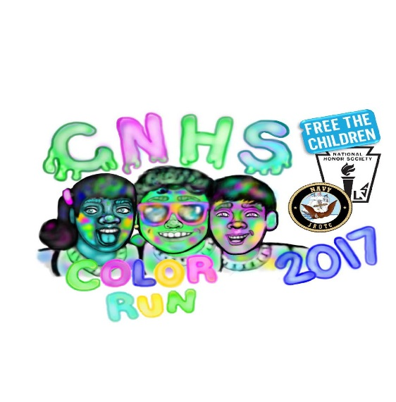

SATURDAY, MAY 13, 2017

BUCKS MILL PARK, COLTS NECK, NJ

**Check-in & Registration:** 8:00am – 8:45am

C**hase the Rainbow 5k Color Run**: 9:00am

**Start / Finish:** Bucks Mill Park, 137 Bucks Mill, Colts Neck

**Race Timing:** Results by Split Second Racing, Chips provided

with registration

**T-Shirts**: Guaranteed to all pre-registrants

This event is hosted by CNHS’s National Honor Society, Navy JROTC, and Free the Children. All proceeds will be donated to the Make a Wish Foundation of NJ, the Alzheimer’s Association, and Free the Children. To learn more about the National Honor Society, Junior ROTC, and Free the Children, or to register for the race, please refer to the website [www.chasetherainbow5k.com](http://www.chasetherainbow5k.com).

**Register for Chase the Rainbow at**

https://www.raceforum.com/chase-the-rainbow-5k-color-run

**For more info about the race go to** [**www.chasetherainbow5k.com**](http://www.chasetherainbow5k.com) **SCAN QR CODE FOR INSTANT ACCESS -------🡪**

**Pre-Registration Fee: $25 adults / $20 (18 and younger)**

**Day-of Registration Fee: $35 adults / $25 (18 and younger)**

-------------------------------------------------------------------------------------------------------------------------------------------

In consideration of the acceptance of my entry, I myself, my representative and assigns do hereby release and discharge Colts Neck High School, the Township of Colts Neck, the race officials, volunteers and sponsors (hereinafter releases) for any claim arising out of my participation in this athletic event. I verify that I have full knowledge of the risks involved and I am physically fit and sufficiently trained to participate in this event. I am at least 18 years of age or have has this release signed by my parent / guardian if I have not yet reached the age of 18.

PLEASE PRINT:

Shirt Size

Small

 Medium

 Large

 X-Large

_____________________________________________________________________________

Last Name First Name Age on Race Day

_____________________________________________________________________________

Address City State Zip Code

_____________________________________________________________________________

Signature (Parent / Guardian if under 18) Date