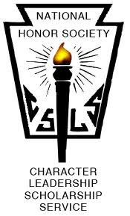
COLTS NECK HIGH SCHOOL McCHESNEY KANE CHAPTER

September 13, 2018

Welcome back seniors! This should be a challenging and exciting year ahead. Many of you are enrolled in AP and Honors classes and in addition to your normal workload, you will be busy visiting colleges and completing applications. Very soon you will see how your hard work at CNHS has paid off when you accept admissions to your dream college, join the military or head out into the workforce. As your NHS advisors we look forward to a challenging and productive year. Please carefully review the information below, frequently check our website (http://coltsnecknhs.weebly.com) and make sure you are signed up to receive Remind texts.

I. Member Requirements.
- Members are expected to participate in community activities or events of a member’s own choosing for at least sixty hours (60) this year.

- Members must complete a minimum of fifteen hours (15) per marking period. All hours per MP are due by the final day of the MP, and hours will not carry over from one MP to the next. Failure to submit the appropriate number of hours will result in probation, and upon being notified of being on probation*, a members will have an additional five (5) days to complete the requisite number of hours. Failure to do so will result in dismissal. Activities or events must be approved by the faculty advisors. Members must have all service activities documented including date, number of hours, signature of on-site supervisor, and thorough explanation of service. The hours from summer service will only count toward the first MP.

- Members must participate in any project sponsored by CNHS NHS. The 60 hours cannot be earned as part of a project that is required by the CNHS NHS.

- Attend all scheduled meetings. A member who has one unexcused absence from scheduled meetings will be placed on probation. A second unexcused absence will result in dismissal. The determination of whether or not an absence is excused is left to the discretion of the Co-Advisors. Illness, school athletic events, and field trips are examples of acceptable excuses. In order to be excused, the Co-Advisors must be notified in writing 24 hours of an absence (with the exception of grave illness or immediate, significant family obligation).

II. Meeting Dates
Sept. 13th Mtg (7:30am, Med Ctr)
Oct. 4th Mtg (am and pm, Med Ctr)
Nov. 1st Mtg (am and pm in Med Ctr)
Dec. 6th Mtg (am only in Auditorium)
Dec. 12th Induction Ceremony (5:30 Check-In, 6pm Start)
Jan. 3rd Mtg (am and pm in Auditorium)
Feb. 7th Mtg (am and pm in Auditorium)
Mar. 7th Mtg (am and pm in Auditorium)
Apr. 4th Mtg (am and pm in Auditorium)
May 2nd Mtg (am and pm in Auditorium)
May 3rd Executive Board Elections for Juniors
June 6th NHS Breakfast & distribution of medals

III. NHS Events
- NHS Apparel Sale – Approved* Designs due by Thursday, October 18th
- Induction Ceremony December 12, 2018 at 6:00pm
- Adopt-a-Family in December
- 5k Color Run, May 2019
- Your suggestions for an organization etc. to donate money? Fundraisers? Events?

IV. Volunteer Opportunities in the Spot Light
- Peer 2 Peer Tutoring: Sign up to help out a peer before or after school – link located on website. See Mrs. Lucarelli for more details.
- 5K NHS Color Run Committee: The committee is looking for members who will work throughout the year to get sponsor money and spread the word about the 5k in May 2018.
- ELL Tutoring on Tuesdays and Thursdays after school beginning late October! Will need students to regularly assist.

V. Submission of Hours
- You are expected to record all hours online and file all hard copies of volunteer hours into your individual folders.
- We will check both online and folders to verify all info is up-to-date and authentic.

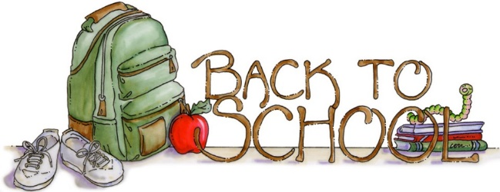

Activities eligible for NHS Required Community Service Hours
1. Hospital Service;
2. Religious Service Projects/Volunteering at a Cultural Center;
3. Teaching Assistant- Chinese School, Hebrew School, CCD, etc.;
4. First Aide/Fire Departments including EMT training/Police Explorers;
5. Girl/Boy Scouts-Community Events and Eagle Scout Projects only, NO MEETING HOURS;
6. Habitat for Humanity;
7. ASPCA/SPCA;
8. Public Library;
9. Sports Camps- Volunteer service only;
10. Monmouth County Parks (VIP: Volunteers in Parks);
11. American Cancer Society;
12. Tutoring associated with a structured organization- Private tutoring not accepted;
13. Youth Ministries- Tutoring, outreach, etc.;
14. Women’s Club;
15. Mission/Relief work projects;
16. Soup Kitchens/Lunch Break;
17. Senior Centers, Nursing Homes, Adopt a Grandparent;
18. Love Inc./Project Angel;
19. Environmental Projects;
20. Preventative Drug, Alcohol, Violence & Abuse Programs;
21. Family Career Community Leaders of America (FCCLA);
22. Red Cross (Blood Drives, Emergency preparedness, etc.);
23. United Way Big Brothers/Big Sisters;
24. Adopt a Highway;
25. DECA Club volunteer hours;
26. 4-H Club volunteer hours;
27. Fundraising hours for non-profit organizations;
28. Driver Safety Program;
29. Elementary/Middle School Help; and
30. Assistant for Youth Team (with verification from coach).

Activities NOT eligible for National Honor Society Required Community Service Hours
1. Service at private doctor’s office/EMO;
2. Service at a private law firm;
3. Service at a family owned business or private business of any type;
4. Private tutoring (not done through an established organization);
5. Babysitting (paid or unpaid);
6. Assisting a neighbor, friend, peer;
7. Work with an organization where volunteering is required for your or someone else’s
membership (pay to play athletic leagues where children or parents must volunteer
time in order for a child to play);
8. In school activities that are a required component of a club and/or class;
9. Internships (personal development is not community service);
10. Political Campaigns;
11. Job Training, CIT/Counselor in Training: Job training is considered as getting ready for a
paid position and therefore is not considered volunteer work even though it is unpaid;
12. If you received any pay or benefits for your work it is not considered volunteer work;
13. Chores (even if you do them for someone outside your family);
14. Jobs and/or Employment (even if unpaid);
15. Model United Nations;
16. Math/Science competitive teams; and
17. Fundraising for a club or sports team.
Note: Confirm with the NHS Advisor regarding activities not listed.

