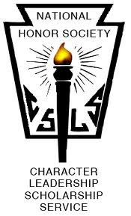

COLTS NECK HIGH SCHOOL McCHESNEY KANE CHAPTER

NEWSLETTER
March 7, 2019

VISIT OUR ONLINE APPAREL STORE TO STOCK UP ON YOUR NHS GEAR!
NHS APPAREL 2019
1. Meeting dates:
Apr. 4th Mtg (am and pm in Auditorium)
May 2nd Mtg (am and pm in Auditorium)
May 3rd Executive Board Elections for Juniors
June 6th NHS Breakfast & distribution of medals

2. Bowling Fundraiser
When: Thursday, March 14th
Where: TBA
What: Get your friends and come bowl for two hours, 7-9pm.
Why: To have fun! Plus prizes will be awarded to top scoring individuals and teams.

3. 5k Color Run is on May 18, 2018 (Rain Date May 19th)
- We need … runners /walkers! Sign up family and friends to participate.
- We need … sponsors! Distribute sponsor info to family and friends!
- We need … prize donations! Hit up local businesses and see if they are willing to donate prizes (e.g. gift certificates, etc)
- Race committee lunch meetings?

4. Do you know a fellow member of NHS who is doing great things? Volunteering his / her time and making a real difference in the community? We would like to celebrate that person, thank him/her for making a difference. Send an email to hlucarelli@frhsd.com or dniemierowski@frhsd.com to nominate this person and include a brief explanation of this person’s accomplishments. Submission deadline is February 28th.

